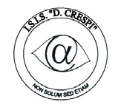 | ISTITUTO DI ISTRUZIONE SECONDARIA “DANIELE CRESPI”  Liceo Internazionale Classico e Linguistico VAPC02701R  Liceo delle Scienze Umane VAPM027011  Via G. Carducci 4 – 21052 BUSTO ARSIZIO (VA)  www.liceocrespi.it-Tel. 0331 633256 - Fax 0331 674770 - E-mail: lccrespi@tin.it  C.F. 81009350125 – Cod.Min. VAIS02700D | 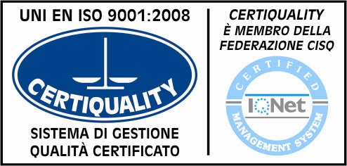  CertINT® 2012

Circ. 157 Busto Arsizio, 5 Novembre 2013
WEB

A tutte le classi quarte e quinte
Copia in aula

OGGETTO: Study in the UK

Trasmetto la sintesi operata dallo sportello internazionalizzazione in merito allo studio e all’orientamento universitario all’estero.

“In the UK there are 100 universities and most part of the undergraduate courses last 3 years.
When you choose a university in the UK, study the environment, there are places like Keele for example that not many people know but offers a lot. Oxford Brookes is considered to be number one new universities.
Think where you want to live, not only where to study. The quality standard of UK universities is consistent.
UK universities have flexible UG (undergraduate) structures with many modular programs.
When you choose a university, keep in mind that official ranking is not reliable.
Think about what you really want to study, look at the subjects and don't forget what you want to do once graduated.
Choose combination of courses, make you degree structure flexible.
Also check teaching style (courses can be both lectures and seminars), assessments (how structured and how often), fees and living expenses (food and accommodation).

Application through UCAS website, with a maximum of 5 choices. Supporting documents normally required are: a certified translation of your diploma; references (not from a family member); Ielts certificate; photocopy of passport or ID.

The normal direct UG (undergraduate) pathway is through UCAS with maturità and Ielts. In case your voto di maturità is low compared to the minimum required and your Ielts level is 0.5 or 1.0 point below what requested, you can enroll on a “Foundation Course”.

Foundation courses are held at colleges and universities. They can last from a minimum of 4 weeks to a maximum of 15 and they normally take place during the months of July, August and September.

These courses are based purely on language and study skills. At the end of the course you don't have to retake Ielts. After a foundation course you should have a solid academic preparation and you can choose where and what to study. Some universities have Foundation Courses on campus and at the end they may offer you a position in what you are interested in.

The academic year starts in September or January.

When you enter UCAS website, you can choose 5 universities. Check entry level and requirements. You have only 5 possibilities, don't waste them.
You need a clear study plan as you write your personal statement, because it is one for 5 different universities.
The choices should be similar among them, try to select 2 high level universities, 2 medium and be ready for 1 plan B.

You will be asked for a reference. This should be possibly from the school, academic, recent, not from friends or relatives and concerning the program chosen. There should be a prediction of “voto di maturità”.

About the English Test Score, you can enter your Ielts certificate even later on.

Deadline for enrolment is 15th January, if you manage before or within Christmas time is better.

Personal statement:
first and most difficult thing to do is stay within the 650 necessary words.
Try to sell you at your best, say why you have chosen a course and how much you have done so far about that. Give relevance to studies in Italy.

Write about the skills you have, what makes you unique, individual and academic praises received so far.
But don't write too much about you and don't give unnecessary information.

It has to be divided into 5 paragraphs:
1) reason/why that course/university/city
2) relevant studies
3) work experience, what you have learnt, was it useful
4) extras about you
5) 1 or 2 sentences or a short statement of what you could bring to the university.

The paragraphs can be independent, they don't have to flow, but try to use grabbing sentences if you feel confident in doing this. Don't put on something you can't prove or maintain after.
Show real passion, talk about challenges, be honest, justify what you write.
Charisma is important.
Check grammar, spelling, but you are not expected to be perfect, you are from another country. Well, it has to make sense of course.
Be reflective, not only descriptive.
Show you can think outside the box.
Take time for it, think about it in your mind, but write it only when your heart is ready to let it go. Humanity is important when you write it.

Scholarship are mainly for PG, postgraduate and are given on need or ability, details are available on the single university wep pages.

Information on student loans and how to apply for them are available on www.gov.uk and UCAS website “02 students apply for fee”. “ (a cura di L. Del Fabro)

Il Dirigente Scolastico
Prof.ssa Cristina Boracchi

