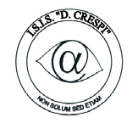 | 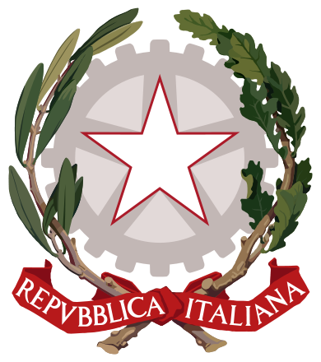  ISTITUTO DI ISTRUZIONE SECONDARIA “DANIELE CRESPI”  Liceo Internazionale Classico e Linguistico VAPC02701R  Liceo delle Scienze Umane VAPM027011  Via G. Carducci 4 – 21052 BUSTO ARSIZIO (VA)  www.liceocrespi.it-Tel. 0331 633256 - Fax 0331 674770 - E-mail: lccrespi@tin.it  C.F. 81009350125 – Cod.Min. VAIS02700D | 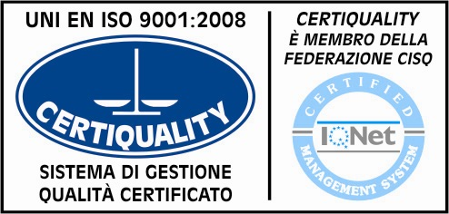  CertINT® 2012

Circ. 177 Busto Arsizio, lì 15 novembre 2013
WEB
Ai Sigg. Docenti – lingua straniera
Agli studenti e ai genitori - classi IV e V anno

OGGETTO: Studying in Europe - a cura dello sportello di internazionalizzazione

Si comunica il risultato della ricerca condotta dallo sportello in merito all’oggetto.

“Sweden
One of the reasons why Sweden is an interesting country is for its landscapes, few people, and a culture in constant evolution.
Sweden is a country with a high standard of living, and has one of he best school system in Europe.
Most universities offer courses both in Swedish and English and the most prestigious organisations are in Gotebord and Uppsala. European students also like a lot places such as Linkoping and Jonkoping.
Universities offer a 3 level system of studies: 3 or 4 year bachelor, 2 year master, and PhD.
Universities are divided in “universitet” which offer lectures and researches and “hogskola”, lectures only.
Most part of courses and professional training take place in public universities. There are no enrolment fees in Sweden, only for some masters.
Important in Sweden are the students associations (nations) which represent the social and academic interests of their members; they welcome new students, especially from abroad, organise events and parties, manage cafeterias, look after the campus gardens. There is a fee to pay to become a member, but it is not an expensive sum.
Most of university degrees have tests in English language. All the universities have offices for international students in order to offer all the necessary information. Ielts is the favourite English certificate. Many universities offer the possibility of attending lectures in Swedish. Courses with a final test both written and spoken, give specil credits.
The academic year starts at the end of August and ends round half June. Enrolments are normally taken during the previous academic year and there are entrance courses. All the faculties are organised in semesters, from August 'till mid January and from mid January 'till June.
“Hogskolan” instead have 4 trimesters (two in winter and two in spring), 7 weeks each, plus a week for exams.
In Sweden life is quite expensive for students from other European countries. There are many places where students can have meals at reasonable prices, but they need a special card for this, card which can also be used at supermarkets. An average monthly sum including accommodation, food, transports, free time, telephone, medical insurance is about €800 in a city like Stockholm, which is the most expensive.
For further information: www.studyinsweden.se

Denmark
The Kingdom of Denmark is a constitutional monarchy with Margarthe II as Queen regnant, member of the European Union since 1973.
Denmark is frequently ranked as the happiest country in the world, and has the world's highest social mobility, a high level of income quality and one of the world's highest per capita income. Denmark is among the founding members of the NATO and the United nations and there are three Danish heritage sites inscribed on the Unesco World Heritage list.
The university system is divided in:
Academy profession degree, 2 years, which offers:
degree from an Academy of Professional Higher Education or a University College;
theory and practice;
internships in Denmark or abroad;
close collaboration with business and industry;
small class sizes and close contact between students and teachers
Professional Bachelor's degree, 3-4 years, which offers:
degree from a University College or an Academy of Professional Higher Education;
specific professions;
theory and practice in one programme;
internships in Denmark or abroad
small class sizes and close contact between students and teachers.
University Bachelor's degree, 3 years, which offers:
research-based education;
degree from a University;
predominantly theoretical courses;
opportunities to undertake study periods or internships abroad;
independent studies as well as project work.
For further information: studyindenmark.dk

Latvia
The Republic of Latvia is a country in the Baltic region of Northern Europe, bordered to the north by Estonia, to the south by Lithuania, to the east by Russia, to the southeast by Belarus and by a maritime border to the west with Sweden. It has a total population of 2,070,371 inhabitants, and it is one of the least populous and least densely populated countries of the European Union. The capital of Latvia is Riga, and the official language is Latvian, one of the most difficul and absurd languages in the world. Latvian culture is based on the German and Swedish ones.
Many people nowadays go and study in Latvia, where the quality of life is improving, Riga is a modern city with one of he best broad band in Europe, shopping centres, monuments and cheap places where to eat.
For further information: studyinlatvia.lv

Germany
It is the first economic powerful country in Europe, fourth in the world, with a territory slightly bigger than the Italian one and a population of 82 million people.
Thanks to a positive economic growth, there have been huge investments in education and research.
Higher education is divided in “universitaten” and “hochschulen” which offer 3 year bachelors and 2 year masters. Students can freely choose their courses and foreign students are helped by a tutor to organise their course of study.
Most courses are only in German, but there is an increasing number of universities which now offer courses in English as well. To enroll a “diploma di maturità” is needed together with a language certificate. After having applied, a form is sent for the official application. Some universities have a restricted number of places available. A list of these universities is available on www.zvs.de.
Applications have to be sent at the beginning of January for courses starting in September, and within the beginning of July for courses starting in January.
Fees vary according to the Land.
For further information: http://studieren.de/study-in-germany.0.html

Spain
Spain is one of the most favourite countries by foreign students for its dynamism, culture and “latinidad”. University offer has a very high standard. University degrees, masters and MBA give the opportunity to cooperate with South American countries.
In Spain there are 70 universities, of which 50 are public.
The system is similar to the Italian “vecchio ordinamento”, after 4 or 5 years a student is “licenciado” and can attend a one or two year master, with a further 2 or 3 year doctorate. The university of Salamanca is the oldest (XIII century) and the Complutense in Madrid the most crowded one. For those interested in finance and management, there are business schools based on an anglo-american organisation in Barcelona, but they are very expensive.
The academic year starts in October and finishes at the end of June.
You need a language certificate in Spanish to enrol, together with your “diploma di maturità” and there is both an entry language test and a general entry test according to the chosen course of study.
For further information: http://www.studyinspain.info/?l=en

France
France offers both university education and professional training and students are engaged in stage activities even before the end of their studies.
Universities in France are divided in “public”, open to all students, and “Grandes Ecoles”, private, but supported by the “Education national”.
The system is 3+2 like in the countries of the European Union following the “Dichiarazione di Bologna”.
The university structure is LMD, Licence, Master and Doctorat. After a 3 year course students get the “licence/bachelor”, which can be followed by a 2 year master. Then there is the third cycle of study, a 4 year doctorat.
For those interested in attending a Grand Ecole, there are 2 year preparation courses for the entry tests.
Most of the courses are in French and it is necessary to have a language certificate to prove the level of knowledge.
Post bachelor and MBA courses are held in English as well, in case there are foreign students.
It is possible to enroll in the semester prior to the beginning of the courses. The academic year starts on 1st October and finishes on 30th June.
For further information: www.studyineurope.eu/study-in-france
and www.campusfrance.org/en
(A cura di: Leila Del Fabro)

Il Dirigente Scolastico
Prof.ssa Cristina Boracchi

